 | THE HISTORY HERALD  August 12th, 2024  AP US History I  www.MrDuncansHistoryClass.com | 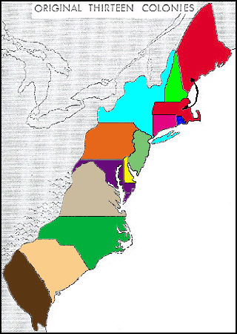

THIS WEEK  Mon 12th Lecture Chap 1/ Native Peoples Analysis  Chap One Packet Due  Summer Reading 1776 Due  Tues 13th Lecture: Chap 2- The Planting of English America  Reader 31-34 / 38-40  Wed 14th Chap 2- The Planting of English America  Reader 31-34 / 38-40  Thur 15th Quiz / The Planting of English Am.  The Starving Time  Fri 16th Documentary We shall Remain – After the Mayflower  NEXT WEEK  Mon 19th Chap 3 – Settling the Northern Colonies  Book Review DUE  Tues 20th Chap 3 – Settling the English Colonies  Wed 21st Documentary God in America – New Adam  Thurs 22nd Chap 4 – Am Life in the 17th Century  Fri 23rd Chap 4 – Am Life in the 17th Century  CHAPTER 2 The Planting of English America, 1500–1733  Focus Questions  1. What international events and domestic changes prompted England to begin colonization?  2. What was it like for the early settlers of Jamestown?  3. Why were Native Americans unable to repel English colonization of North America?  4. What crops were important to the English colonies in the south of North America? How did the cultivation of those crops shape those colonies?  5. How did the English sugar plantations in the Caribbean differ from the English colonies in the south of North America?  6. How did slavery develop in North America during colonization?  7. What features were shared by Virginia, Maryland, South Carolina, North Carolina, and Georgia? What distinguished them from one another?  Chapter Themes  Theme: The English hoped to follow Spain’s example of finding great wealth in the New World, and that influenced the financing and founding of the early southern colonies. The focus on making the southern colonies profitable shaped colonial decisions, including choice of crops and the use of indentured and slave labor. This same focus also helped create economic and cultural ties between the early southern colonies and English settlements in the West Indies.  Theme: The early southern colonies’ encounters with Indians and African slaves established the patterns of race relations that would shape the North American experience—in particular, warfare and reservations for the Indians and lifelong slave codes for African Americans.  Theme: After a late start, a proud, nationalistic England joined the colonial race and successfully established five colonies along the southeastern seacoast of North America. Although varying somewhat in origins and character, all these colonies exhibited plantation agriculture, indentured and slave labor, a tendency toward strong economic and social hierarchies, and a pattern of widely scattered, institutionally weak settlements.  chapter summary  The defeat of the Spanish Armada and the exuberant spirit of Elizabethan nationalism finally drew England into the colonial race. After some early failures, the first permanent English colony was established at Jamestown, Virginia. Initially it faced harsh conditions and Indian hostility, but tobacco cultivation finally brought prosperity and population growth. Its charter also guaranteed colonists the same rights as Englishmen and developed an early form of representative self-government.  The early encounters of English settlers with the Powhatans in Virginia established many of the patterns that characterized later Indian-white relations in North America. Indian societies underwent their own substantial changes as a result of warfare, disease, trade, and the mingling and migration of Indians from the Atlantic coast to inland areas.  Other colonies were established in Maryland and the Carolinas. South Carolina flourished by establishing close ties with the British sugar colonies in the West Indies. It also borrowed the West Indian pattern of harsh slave codes and large plantation agriculture. North Carolina developed somewhat differently, with fewer slaves and more white colonists who owned small farms. Latecomer Georgia served initially as a buffer against the Spanish and a haven for debtors.  Despite some differences, all the southern colonies depended on staple plantation agriculture for their survival and on the institutions of indentured servitude and enslaved Africans for their labor. With widely scattered rural settlements, they had relatively weak religious and social institutions and tended to develop hierarchical economic and social orders.  CHAPTER 3 Settling the Northern Colonies, 1619–1700  Focus Questions  1. What religious turmoil in the Old World resulted in the little colony of Plymouth in the New World?  2. Why was the initial and subsequent colonization of the Massachusetts Bay Colony more successful than Plymouth?  3. How did the colony of Plymouth and Massachusetts Bay Colony contribute to the origins of American independence and government? What were the contributions to American independence and government from the New England Confederation, the Dominion of New England, and the Glorious Revolution?  4. What role did religious intolerance play in the founding of New England colonies other than Plymouth and Massachusetts Bay and in the founding of some middle colonies?  5. Besides England, what other nations influenced the colonization of the Atlantic coast of North America?  6. How did the colonization of Pennsylvania differ from the New England colonies and other middle colonies?  Chapter Themes  Theme: Religious and political turmoil in England shaped settlement in New England and the middle colonies. Religious persecution in England pushed the Separatists into Plymouth and Quakers into Pennsylvania. England’s Glorious Revolution also prompted changes in the colonies.  Theme: The Protestant Reformation, in its English Calvinist (Reformed) version, provided the major impetus and leadership for the settlement of New England. The New England colonies developed a fairly homogeneous social order based on religion and semicommunal family and town settlements.  Theme: Principles of American government developed in New England with the beginnings of written constitutions (Mayflower Compact and Massachusetts’s royal charter) and with glimpses of self-rule seen in town hall meetings, the New England Confederation, and colonial opposition to the Dominion of New England.  Theme: The middle colonies of New Netherland (New York), Pennsylvania, New Jersey, and Delaware developed with far greater political, ethnic, religious, and social diversity, and they represented a more cosmopolitan middle ground between the tightly knit New England towns and the scattered, hierarchical plantation in the South.  chapter summary  The New England colonies were founded by English Puritans. While most Puritans sought to purify the Church of England from within, and not to break away from it, a small group of Separatists—the Pilgrims—founded the first small, pious Plymouth Colony in New England. More important was the larger group of nonseparating Puritans, led by John Winthrop, who founded the Massachusetts Bay Colony as part of the Great English Migration of Puritans fleeing persecution in England in the 1630s.  A strong sense of common purpose among the first settlers shaped the Massachusetts Bay Colony. Because of the close alignment of religion and politics in the colony, those who challenged religious orthodoxy, among them Anne Hutchinson and Roger Williams, were considered guilty of sedition and driven out of Massachusetts. The banished Williams founded Rhode Island, by far the most religiously and politically tolerant of the colonies. Other New England settlements, all originating in Massachusetts Bay, were established in Connecticut, Maine, and New Hampshire. Although they shared a common way of life, the New England colonies developed with a substantial degree of independence.  The middle colonies took shape quite differently. New York, founded as New Netherland by the Dutch and later conquered by England, was economically and ethnically diverse, socially hierarchical, and politically quarrelsome. Pennsylvania, founded as a Quaker haven by William Penn, also attracted an economically ambitious and politically troublesome population of diverse ethnic groups.  With their economic variety, ethnic diversity, and political factionalism, the middle colonies were the most typically American of England’s thirteen Atlantic seaboard colonies. | Chapter 2  The Planting of English in America  King Henry VIII  Elizabeth I  Sir Walter Raleigh  Roanoke Island Colony  “The Lost Colony.”  Spanish Armada  Shakespeare  enclosure  primogeniture  joint-stock company  Virginia Company  Captain John Smith  Powhatan  Pocahontas.  Lord De La Warr  1st Anglo-Powhatan War  John Rolfe.  2nd Anglo-Powhatan War  Virginia:  tobacco.  Maryland  Catholic Haven  Act of Toleration,  The West Indies:  Charles II  “The Restoration.”  “Slave Codes”  North Carolina  Georgia  The Buffer Colony  James Oglethorpe.  John Wesley  Iroquois League  Iroquois Confederation  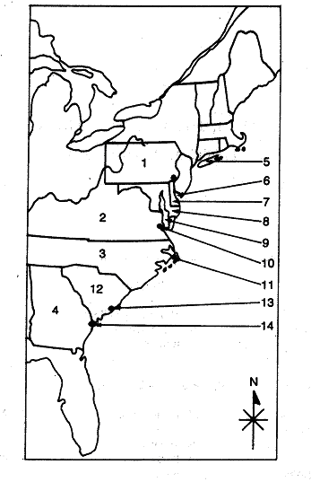  Chapter 3  Settling the Northern Colonies  Puritanism  Martin Luther  “predestination”  “Protestant Work Ethic”  King Henry VIII  Puritans,  “visible saints”  Church of England (AKA, the Anglican Church)  King James I,  Pilgrims or Separatists,  Captain Myles Standish (AKA, “Captain Shrimp”)  Mayflower Compact,  William Bradford,  Commonwealth  John Winthrop  Congregational Church  John Cotton,  Anne Hutchinson  “antinomianism”.  Reverend Thomas Hooker  Fundamental Orders.  Squanto,  Pequot War,  Metacom (aka King Philip)  King Philip’s War  Independence  New England Confederation.  Dominion of New England  Navigation Acts.  Sir Edmund Andros.  Glorious Revolution  William and Mary  New Netherland  Henry Hudson  patroonships  New Sweden  Peter Stuyvesant  Duke of York,  New Amsterdam was renamed New York.  The Dutch Legacy  The Quakers  William Penn,  New York, New Jersey,  Delaware, and Pennsylvania  Benjamin Franklin

