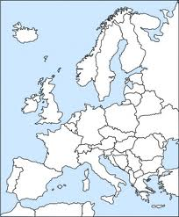 | THE HISTORY HERALD  August 1st, 2024  AP EURO  www.MrDuncansHistoryClass.com | 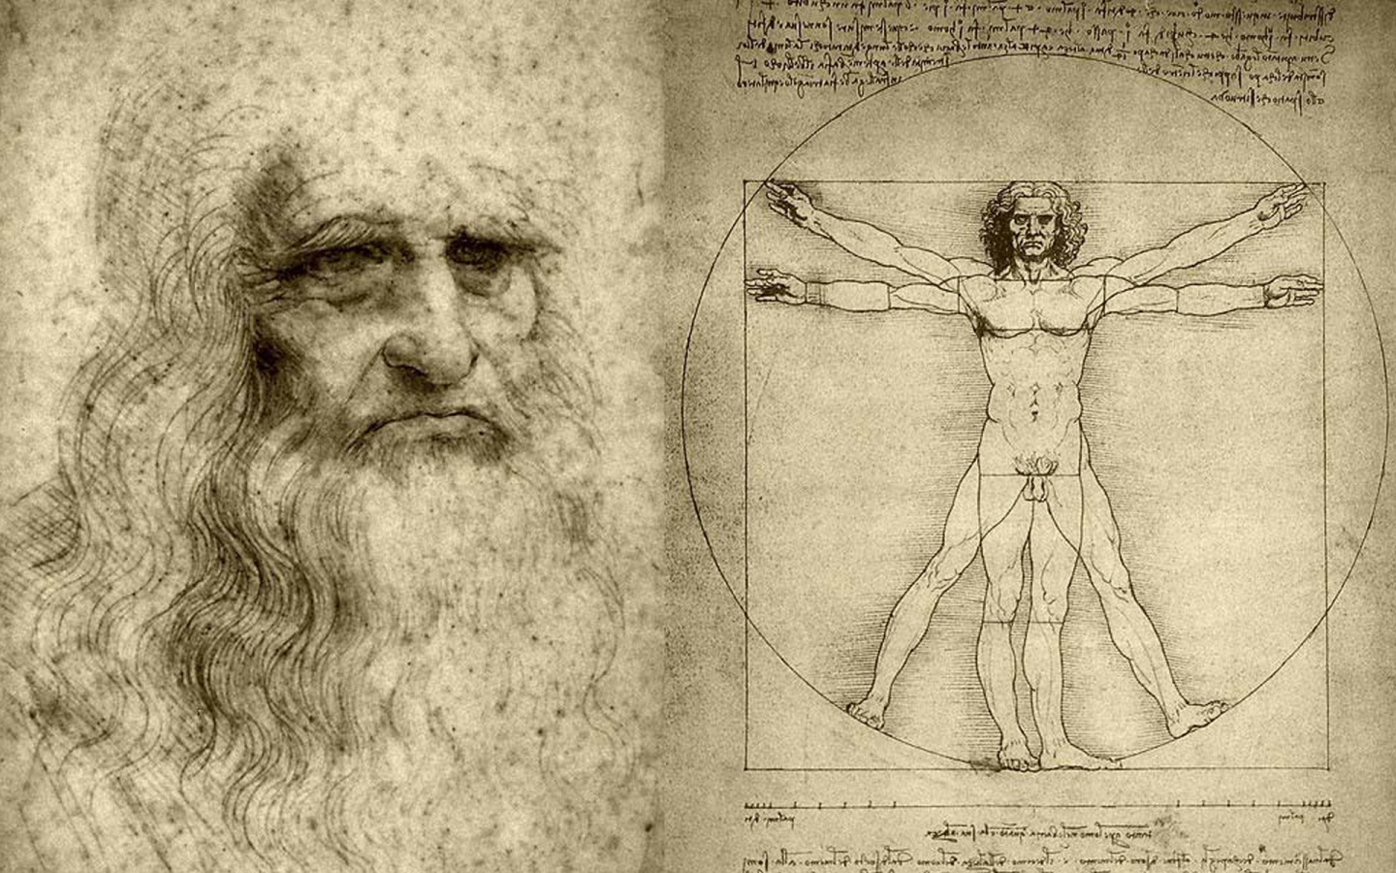

IMPORTANT DATES:  June 3rd – Email me  Darrell.Duncan@sumnerschools.org  July 29 – Registration for classes  Our textbook is online also at the class website under the chapter heading if you want to get ahead  SIGN IN TO GOOGLE CLASSROOM BY Friday before hawktime – CODE: f3km7wr  THIS WEEK  Wed 7th World Lit only by Fire /Syllabus and Intro  Sign in to Google Classroom: f3km7wr  Thur 8th Black Death documentary Chap 11 pg 299 - 307  Fri 9th Chapter 11 pg 307 - 313 100 Years War  NEXT WEEK  Mon 12th SUMMER READING DUE  Hiring a Plague Doctor  Tues 13th What does 30 minutes look like  Bring book and blank NOTECARDS  Chap 11 pg 313-329  Wed 14th Countries and Capitals Quiz 1 hour/ Chap 11  Thurs 15th Chap 12 pg 331-336  Fri 16th Story of Glass Documentary 1 hour  Over the weekend Chapter 11 EXAM ( online )  THE NEXT WEEK:  Mon 19th CHAPTER 11 Notecards DUE  Physical map of Europe Quiz / Chap 12 Online Lecture  Reading Questions  1) What was the Black Death? What were the preexisting conditions in Europe that allows it to be so devastating?  2) What are the short and long term effects on European religion and society? (i.e. What were the changes that resulted from the Black Death?)  3) Discuss factors that led to the urban and rural revolts in the 14th century. Was desperate poverty a chief cause? Why or why not?  4) What were the causes of the 100 Years War (make sure to use specific examples to explain your answer)? How was France changed politically as a result of the war?  5) What were the problems facing the governments of England, France, and the German lands at the end of the Middle Ages?  6) Describe how and why the Church was declining in power in the 14th century. How did the religious leaders respond?  7) What were the effects of the Church’s declining power on European culture, popular religion, and literature?  MAP EXERCISES  1. The Spread of the Black Death. MAP 11.1. What areas were largely spared from the impact of the plague, and was geography, including distance from the eastern Mediterranean, the primary explanation? (page 285)  2. The Hundred Years’ War. MAP 11.2. Compare the lands in France controlled in England in 1360 with those held in 1429. How do they differ? What part did geographical proximity to England as well as the regions in France historically and traditionally under English control play in England’s successes during the war? (page 294) | Identifications Chapter 11  1. “little ice age”  2. Black Death  3. bubonic plague  4. Yersina pestis  5. pneumonic plague  6. Giovanni Boccaccio’s Decameron  7. flagellants  8. pogroms  9. Statute of Laborers  10. the Jacquerie  11. Wat Tyler and John Ball  12. Florence’s ciompi  13. the longbow  14. the Battle of Crecy  15. Henry V  16. the Battle of Agincourt  17. Joan of Arc  18. Orleans  19. Charles the dauphin/VII  20. gunpowder  21. the gabelle and the taille  22. dukes of Burgundy and Orleans  23. Golden Bull of Charles IV  24. Italian communes  25. the Visconti and the d’Este  26. condottieri  27. grandi and popolo grasso  and popolo minuto  28. Council of Ten and the doge  29. Pope Boniface VIII’s Unam Sanctam  30. Avignon  31. Catherine of Siena  32. Great Schism  33. the Antichrist  34. Conciliarism  35. Marsiglio of Padua  36. Council of Constance  37. purgatory  38. good deeds and pilgrimages  39. Meister Eckhart  40. Modern Devotion  41. Brothers of the Common Life  42. William of Occam and nominalism  43. the vernacular  44. Dante’s Divine Comedy  45. Petrarch’s sonnets  46. Chaucer’s Canterbury Tales  47. Christine de Pizan  48. Giotto  49. the “four humors”  50. clocks, eyeglasses, and paper
QUESTIONS FOR THE PRIMARY SOURCES (BOXED DOCUMENTS)
1. “’The Black Death’ from Giovanni Boccaccio, Decameron”: What evidence does this excerpt provide on the total collapse of Italian urban civilization as it was structured before the advent of the plague? What role does religion and the Church play in Boccaccio’s story of the Florentine plague? (page 301)

2. “A Medieval Holocaust: The Cremation of the Strasbourg Jews”: What were the specific reasons stated in the document that led to the cremation of the Strasbourg Jews? What were the several possible motives–religious, economic, and others–that led to the killing of many Jews during the Middle Ages, particularly in the aftermath of the Black Death? (page 304)

3. “A Revolt of French Peasants”: Why did the peasants react so strongly against their noble lords? What seem to be the principal motivations of their action? How reliable do you believe this source to be as an accurate account of what happened? Are there any possible connections between the onset of the Black Death in 1347 and the revolt of the French peasants in 1358? If so, what are they? (page 307)

4. “A Feminist Heroine: Christine de Pizan or Joan of Arc”: Is Christine de Pizan’s poem about the triumphs of Joan of Arc a “feminist” literary work? Why or why not? (Define “feminist.”) What are the religious references and allusions in the poem? What are the references to the classical world? In subject matter, is there anything “modern” in the poem? Does the work better reflect the waning Middle Ages or the waxing Renaissance? How and why? (page 312)

5. “Dante's Vision of Hell”: What realism does Dante convey with this scene? How would this piece of literature compare with earlier medieval works? Why would the church oppose this work? What lessons do you think this work was intended to teach its readers? (page 323)

6. “The Legal Rights of Women”: What socioeconomic and socio-political conditions in late medieval Europe conjoined, in your opinion, to “infantize” women and severely limit their legal rights as these documents show? Were these attitudes new to the High and Later Middle Ages? If so, why? Who would benefit the most from the legal disempowerment of women? (page 326)

