 | THE GOVERNMENT GAZETTE  January 9th, 2023  Darrell.Duncan@Sumnerschools.org  www.MrDuncansHistoryClass.com |  | 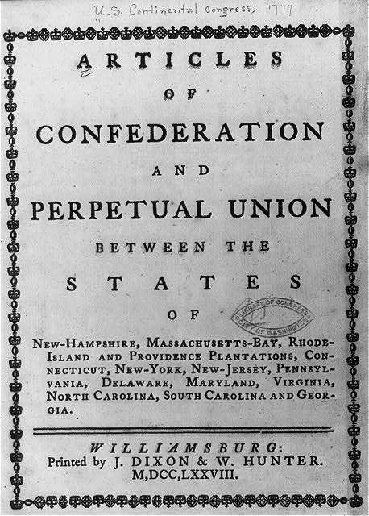
NEXT WEEK -  Monday 9th Chap 1pg 9-15  Tuesday 10th Chap 1 pg 15- 23 Political Spectrum  Reading Quiz (pg 2-15)  Wednesday 11th Packet Due  Locke/Montesquieu/Rousseau – Come Prepared  Thursday 12th Chap 2 pg 24 – 30  Outside Reading ( Declaration of Independence)  Friday 13th Chap 2 30 - 37  Catch up and Current Events DUE  Chapter 1 Test will be online – open Friday Jan 13 at 4pm to Sunday night Jan 15 at 12 ( Midnight) For this first test you will be given TWO opportunities to take it and it will record the BEST SCORE. It will contain vocabulary, multiple choice, and short answer.  Monday 16th NO SCHOOL  Tuesday 17th Chap 2 pg 38 - 44  Outside Reading ( Federalist Papers #10)  Wed 18th Chap 2 pg 44 – 57  Thurs 19^{h} Chap 2 Finish Lecture and Discussion  Outside Reading ( Brutus 1)  Fridy 20th CURRENT EVENTS DUE  CHAPTER TWO EXAM IS Monday JAN 23rd  Weaknesses of the AOC Strengths of the CON  THE GREAT COMPRIMISE  Virginia Plan New Jersey Plan  CONNECICUT COMPROMISE  Who:  What:  Chapter 2: LEARNING OBJECTIVES  A. Learning Objectives  2.1 Explain the ideas behind the American Revolution and how these ideas shaped the Constitution  2.2 Identify the causes of the failure of the Articles of Confederation  􀂾2.3 2.3 Describe the delegates to the Constitutional Convention and the core  ideas they shared  􀂾2.4 2.4 Identify three types of issues the delegates to the Constitutional  Convention confronted and how the Constitution resolved these issues  2.5 Explain the Madisonian system and how it addressed the dilemma of reconciling majority rule with the protection of minority interests  2.6 Contrast the Federalists and Anti-Federalists in terms of their background and their positions regarding government  2.7 Explain the various routes to formal amendment of the Constitution and how the Constitution changes informally  2.8 Explain whether the Constitution establishes a majoritarian democracy  and how it limits the scope of government |  | Chapter 2  THEMES in Chap 2  Origins in American Government  Our political beginnings  Coming Independence  Critical Period  Creating the Constitution  Ratifying the Constitution  WORD LIST  Lecture and Chapter  Representative Assembly  Mayflower Compact  Fundamental Orders of Connecticut  First Continental Congress  Second Continental Congress  Thomas Paine and Common Sense  Declaration of Independence 27  Natural Rights 28  Social Contract  Consent of the Governed 28  Unicameral Legislature  Confederation  State  Articles of Confederation  (AOC) 30  Accomplishments under the AOC  Weaknesses of the AOC  Shays Rebellion 33  Factions Among the Delegates  Constitution 26  Virginia Plan 35  New Jersey Plan 35  Bicameral Legislature  Connecticut Compromise 37  The “Great” Compromise  Supremacy Doctrine  The 3/5 Compromise  Limited Government 28  Writ of Habeas Corpus 39  Separation of Powers 41  Madisonian model  Checks and Balances 42  Republic 43  Electoral College  Federal System  Ratification  US Constitution 34  Factions 34  Federalist 44  Federalist Papers 44  Anti Federalist 44  Beard’s Theory  Bill of Rights 45  Amending the Constitution  Equal Rights Amendment  (ERA) 48  Executive Agreement  Judicial Review 50  Marbury v Madison 50
  WHO:  WHAT: | WHO:  WHAT:

What is the definition and difference between a Liberal and a Conservative?

What is the definition of a Moderate?

What is the difference between a Radical and a Reactionary?

Can you give an example of Anarchy? Historical or Present Day

Can you give several examples of Fascist or a Dictator? Historical and Present Day

