 | THE HISTORY HERALD  August 19th, 2024  AP US History I  www.MrDuncansHistoryClass.com | 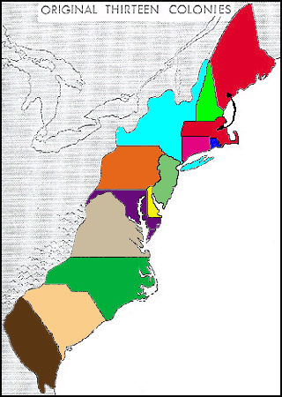

THIS WEEK  Mon 19th Chap 2- The Planting of English America  Book Review DUE  Tues 20th Chap 3 – Settling the Northern Colonies  Wed 21st Documentary We shall Remain – After the Mayflower  Thurs 22nd Chap 3 – Settling the English Colonies  Fri 23rd Chap 3 – Settling the English Colonies  Reader 48-52 BRING YOUR READER  NEXT WEEK  Mon 26th Chap 3 – Settling the English Colonies  Tues 27th Documentary God in America – New Adam  with Video Guide  Wed 28th Chap 4 – Am Life in the 17th Century  Reader 73-77  Thurs 29th Chap 4 – Am Life in the 17th Century  Reader 77-80  OUTLINE FOR CHAPTER 4 is DUE  See Templet in right column -3rd Page  Fri 30th Chap 4 /5 Catch up day?  CHAPTER 3 Settling the Northern Colonies, 1619–1700  Focus Questions  1. What religious turmoil in the Old World resulted in the little colony of Plymouth in the New World?  2. Why was the initial and subsequent colonization of the Massachusetts Bay Colony more successful than Plymouth?  3. How did the colony of Plymouth and Massachusetts Bay Colony contribute to the origins of American independence and government? What were the contributions to American independence and government from the New England Confederation, the Dominion of New England, and the Glorious Revolution?  4. What role did religious intolerance play in the founding of New England colonies other than Plymouth and Massachusetts Bay and in the founding of some middle colonies?  5. Besides England, what other nations influenced the colonization of the Atlantic coast of North America?  6. How did the colonization of Pennsylvania differ from the New England colonies and other middle colonies?  Chapter Themes  Theme: Religious and political turmoil in England shaped settlement in New England and the middle colonies. Religious persecution in England pushed the Separatists into Plymouth and Quakers into Pennsylvania. England’s Glorious Revolution also prompted changes in the colonies.  Theme: The Protestant Reformation, in its English Calvinist (Reformed) version, provided the major impetus and leadership for the settlement of New England. The New England colonies developed a fairly homogeneous social order based on religion and semicommunal family and town settlements.  Theme: Principles of American government developed in New England with the beginnings of written constitutions (Mayflower Compact and Massachusetts’s royal charter) and with glimpses of self-rule seen in town hall meetings, the New England Confederation, and colonial opposition to the Dominion of New England.  Theme: The middle colonies of New Netherland (New York), Pennsylvania, New Jersey, and Delaware developed with far greater political, ethnic, religious, and social diversity, and they represented a more cosmopolitan middle ground between the tightly knit New England towns and the scattered, hierarchical plantation in the South.  chapter summary  The New England colonies were founded by English Puritans. While most Puritans sought to purify the Church of England from within, and not to break away from it, a small group of Separatists—the Pilgrims—founded the first small, pious Plymouth Colony in New England. More important was the larger group of nonseparating Puritans, led by John Winthrop, who founded the Massachusetts Bay Colony as part of the Great English Migration of Puritans fleeing persecution in England in the 1630s.  A strong sense of common purpose among the first settlers shaped the Massachusetts Bay Colony. Because of the close alignment of religion and politics in the colony, those who challenged religious orthodoxy, among them Anne Hutchinson and Roger Williams, were considered guilty of sedition and driven out of Massachusetts. The banished Williams founded Rhode Island, by far the most religiously and politically tolerant of the colonies. Other New England settlements, all originating in Massachusetts Bay, were established in Connecticut, Maine, and New Hampshire. Although they shared a common way of life, the New England colonies developed with a substantial degree of independence.  The middle colonies took shape quite differently. New York, founded as New Netherland by the Dutch and later conquered by England, was economically and ethnically diverse, socially hierarchical, and politically quarrelsome. Pennsylvania, founded as a Quaker haven by William Penn, also attracted an economically ambitious and politically troublesome population of diverse ethnic groups.  With their economic variety, ethnic diversity, and political factionalism, the middle colonies were the most typically American of England’s thirteen Atlantic seaboard colonies.  CHAPTER 4 American Life in the Seventeenth Century, 1607–1692  Focus Questions  1. How did the climate in the southern colonies influence life expectancy, family life, immigration, and economic development?  2. What role did Bacon’s Rebellion play in the adoption and expansion of slavery in the southern colonies?  3. How were life expectancy, family life, immigration, and economic development different in New England as compared with the southern colonies?  4. What were the differences in the legal standing of women in the southern colonies and in the New England colonies?  5. In what ways were all American colonists similar?  Chapter 4 Themes  Theme: In the Chesapeake region, seventeenth-century colonial society was characterized by disease-shortened lives, weak family life, and a social hierarchy that included hardworking planters at the top and restless poor whites and enslaved Africans at the bottom.  Theme: By contrast, early New England life was characterized by healthy, extended life spans, strong family life, closely knit towns and churches, and a demanding economic and moral environment.  chapter 4 summary  Life was hard in the seventeenth-century southern colonies. Disease drastically shortened life spans in the Chesapeake region, even for the young single men who made up the majority of settlers. Families were few and fragile, with men greatly outnumbering women, who were much in demand and seldom remained single for long.  The tobacco economy first thrived on the labor of white indentured servants, who hoped to work their way up to become landowners and perhaps even become wealthy. By the late seventeenth century, however, this hope was increasingly frustrated and the discontents of the poor whites exploded in Bacon’s Rebellion.  With white labor increasingly troublesome, slaves (earlier a small fraction of the workforce) began to be imported from West Africa by the tens of thousands in the 1680s and soon became essential to the colonial economy. By contrast with the South, New England’s clean water and cool air contributed to a healthy way of life, which added ten years to the average English life span. The New England way of life centered on strong families and tightly knit towns and churches, which were relatively democratic and equal by seventeenth-century standards. By the late seventeenth century, however, social and religious tensions developed in these narrow communities, as the Salem witch hysteria dramatically illustrates.  Rocky soil forced many New Englanders to turn to fishing and merchant shipping for their livelihoods. Their difficult lives and stern religion made New Englanders tough, idealistic, purposeful, and resourceful. In later years they spread these same values across much of American society.  Seventeenth-century American society was still almost entirely simple and agrarian. Would-be aristocrats who tried to recreate the social hierarchies of Europe were generally frustrated. | 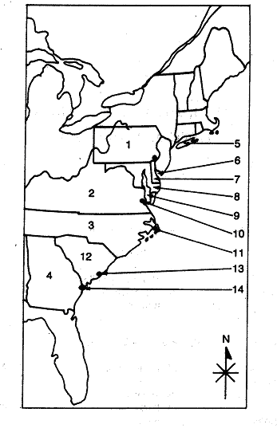  Chapter 3  Settling the Northern Colonies  Puritanism  Martin Luther  “predestination”  “Protestant Work Ethic”  King Henry VIII  Puritans,  “visible saints”  Church of England (AKA, the Anglican Church)  King James I,  Pilgrims or Separatists,  Captain Myles Standish (AKA, “Captain Shrimp”)  Mayflower Compact,  William Bradford,  Commonwealth  John Winthrop  Congregational Church  John Cotton,  Anne Hutchinson  “antinomianism”.  Reverend Thomas Hooker  Fundamental Orders.  Squanto,  Pequot War,  Metacom (aka King Philip)  King Philip’s War  Independence  New England Confederation.  Dominion of New England  Navigation Acts.  Sir Edmund Andros.  Glorious Revolution  William and Mary  New Netherland  Henry Hudson  patroonships  New Sweden  Peter Stuyvesant  Duke of York,  New Amsterdam was renamed New York.  The Dutch Legacy  The Quakers  William Penn,  New York, New Jersey,  Delaware, and Pennsylvania  Benjamin Franklin  Chapter 4  Identify and state the historical significance of the following:  1. William Berkeley  2. Nathaniel Bacon  3. Yarrow Mamout  4. William Bradford  5. Matthew Hopkins  6. indentured servitude  7. slave codes  8. headright system  9. jeremiads  10. middle passage  11. freedom dues  12. “witch hunting”  13. Yankee ingenuity  14. family stability  15. conversions  16. Bacon's Rebellion  17. Leisler's Rebellion  18. Half-Way Covenant  19. African American  20. New England Primer  OUTLINE TEMPLET FOR CHAPTER FOUR  What do you think is important to go under these Headings?  I. The Unhealthy Chesapeake  II. The Tobacco Economy  headright system  III. Frustrated Freemen and Bacon’s Rebellion  Nathaniel Bacon  IV. Colonial Slavery  slave codes  V. Africans in America  Stono River Rebellion  VI. Southern Society  VII. The New England Family  VIII. Life in the New England Towns  IX. The Half-Way Covenant and the Salem Witch Trials  - “jeremiads.”  - “Half-Way  Covenant.”  3. Salem  X. The New England Way of Life  XI. The Early Settlers’ Days and Ways  XII. Makers of America: From African to African-American

