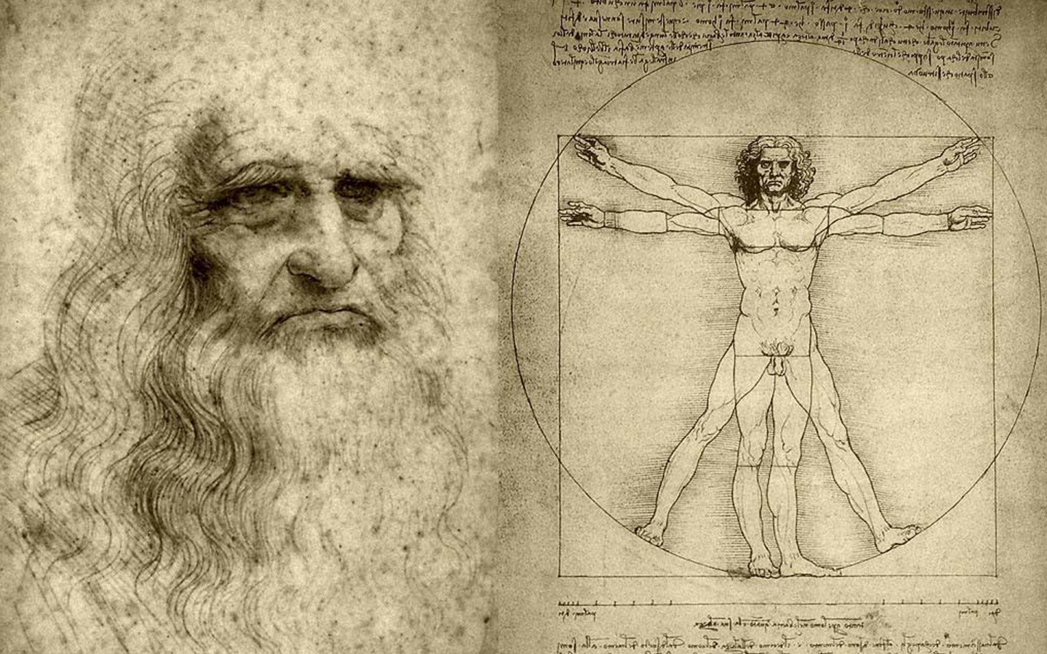 | THE HISTORY HERALD  August 12th, 2024  AP EURO  MrDuncansHistoryClass.com | 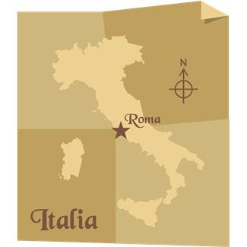

THIS WEEK  Mon 12th SUMMER READING DUE  Hiring a Plague Doctor  Tues 13th Story of Glass Documentary 1 hour  Take an online PRACTICE quiz  Wed 14th What does 30 minutes look like  Bring book and blank NOTECARDS  Chap 11 pg 313-329  Thurs 15th Countries and Capitals Quiz 1 hour/ Chap 11  Fri 16th Chap 12 pg 331-336  Over the weekend Chapter 11 EXAM (online)  NEXT WEEK:  Mon 19th CHAPTER 11 Notecards DUE  Physical map of Europe Quiz / Chap 12 Online Lecture  Tues 15th Chap 12 pg 331-336  Wed 16th Chap 12 pg 337-338 Box Document  Box Document – BRING BOOK  Thurs 17th Chap 12 Lecture pg 338 - 343  Fri 18th Hawk Time: Medici Documentary I / Lecture  THE NEXT WEEK  Mon 21st Chap 12 Lecture pg 343-349  Tues 22nd Chap 12 Lecture pg 349-356  Wed 23rd Chap 12 Lecture 356-363  Reading Questions  - Describe the economic, social, and familial changes that took place during the Renaissance  - What does the term ‘Renaissance’ mean? What areas of life did if affect most? Give specific examples. Does the Renaissance represent a sharp break from the Middle Ages or a continuation of the Medieval Period?  - What was the role Castiglione played in the development of Italian courtly society? Describe his ideal courtier.  - What were the distinctive characteristics of the Renaissance artists? How does their art reflect the political and social events of the period?  - Define Renaissance humanism. What effects did it have on theories and practices in education? Who were the humanists? What were their goals? Did they achieve them?  - How did Machiavelli deal with the issue of political power? How should a prince act?  - How did the printing press change European society?  - Compare and contrast Italian and Northern styles of the Renaissance art. Which is now considered more universal in appeal? Why? | Identifications Chapter 12  1.Renaissance  2. Jacob Burckhardt  3. Leon Battista Alberti  4. Hanseatic League  5. House of Medici  6. Castiglione’s Book of the Courtier  7. condottieri  8. Francisco Sforza  9. Cosimo d’Medici  10. the Papal States  11 Isabella d'Este  12. Peace of Lodi and balance of power  13. 1527 sack of Rome  14. Machiavelli’s The Prince  15. civic humanism  16. Petrarch  17. Leonardo Bruni’s The New Cicero  18. Lorenzo Valla  19. Marcilio Ficino and neoplatonism  20. Renaissance hermeticism  21. Pico della Mirandola’s Oration  22. “liberal studies”  23. Francesco Guicciardini  24. Johannes Gutenberg  25. Masaccio  26. Lorenzo the Magnificent  27. Botticelli’s Primavera  28. Donatello’s David  29. Brunelleschi’s dome  30. High Renaissance  31. Leonardo da Vinci  32. Raphael  33. Michelangelo  34. Sistine Chapel’s David  35. Bramante and Saint Peter’s  36. Giorgio Vasari’s Lives of the Artists  37. Northern Renaissance  38. Jan van Eyck  39. Albrecht Durer  40. madrigals  41. “new monarchies”  42. Louis XI the Spider and Henry VII  43. Ferdinand and Isabella  44. Spanish Inquisition  45. the Habsburgs  46. Ivan III  47. Constantinople and 1453  48. John Wyclif and John Hus  49. Pius II’s Execrabilis  50. Renaissance pope
- Describe the way in which Spain was united. Who benefited and who was hurt?
What were the new heresies of the Renaissance period? How did they differ and how were they like
previous ones (you may have to look at earlier chapters to answer this one). How was the Church’s
reaction to them like or unlike reaction to previous ones?
- Describe the Renaissance papacy by discussing its major figures, their lives, their accomplishments. Had you been alive during this time, what would you have suggested as remedies to their problems?
MAP EXERCISES
1. Renaissance Italy. MAP 12.1. Because of historical proximity, what likely role did ancient Rome play in explaining why the Renaissance began in Italy? If so, why not Greece? Would the Renaissance have evolved in the same manner if Italy had been politically united, say under the Holy Roman Empire or the Papacy, rather than made up of several different and competitive states? (page 339)

2. Europe in the Second Half of the Fifteenth Century. MAP 12.2. What are the geographical and historical reasons why state building was most successful in England, France, and Spain, and less successful in Italy and the Holy Roman Empire? (page 357)

3. The Iberian Peninsula. MAP 12.3. What geographical and political changes resulted from the marriage of Isabella of Castile to Ferdinand of Aragon? How might that union have affected Muslim power in Spain? What role did Portugal’s geographical position play in its focus elsewhere than the Mediterranean in its quest for trade, wealth, and power? (page 358)

4. The Ottoman Empire and Southeastern Europe. MAP 12.4. Compare and contrast Byzantine territory in 1180 with its 1403 domains. What factors might account for that decline? Was Ottoman success against the Byzantines the result of Ottoman strengths or Byzantine weaknesses or both? What geographical factors could explain why the West gave little support to the Byzantine Empire in the fifteenth century? (page 360)

QUESTIONS FOR THE PRIMARY SOURCES (BOXED DOCUMENTS)
1. “A Renaissance Banquet”: Describe the kinds of people who would be present at a banquet where the foods listed on this menu would be served. What does this excerpt tell you about the material culture of the Renaissance and the associations of food with social status? How would a banquet in the twenty-first century differ in its menu from that given by Pope Pius V in the sixteenth century? (page 333)

2. “Marriage Negotiations”: WE WILL DO THIS ONE IN CLASS pg337-338 ”: What were the most important considerations in marriage negotiations? Why were they so important? What were the secondary considerations, and why were they secondary? Why and to which segments of society was formal marriage important to in the Renaissance?

3. “The Letters of Isabella d’Este”: What do these letters reveal about the character of Isabella and about the attributes and strategies of expression upon which noble females had to rely for effective participation in high politics? What does Isabella’s second letter suggest about her marriage and her relationship with her husband? (page 341)

4. “Machiavelli: ‘Is It Better to Be Loved than Feared?’”: What does Machiavelli have to say about being loved rather than feared? How do his theories in this regard make his politics modern and distinguish his advice from Greco-Roman notions of good rulership? Are Machiavelli’s comments in the excerpt at all relevant to today’s democratic politics? (page 344)

5. “Petrarch: Mountain Climbing and the Search for Spiritual Contentment”: What were Petrarch’s motives for climbing Mount Ventoux? What bothers Petrarch about his own intellectual pursuits? Why did the excerpt from St. Augustine’s Confessions disturb him so much? How does the conflict within himself reflect the historical debate about the nature of the Renaissance? (page 345)

6. “Pico della Mirandola and the Dignity of Man”: What does Pico mean by the “dignity of man”? Why would Pico be regarded as one of the most representative examples of a Renaissance man? Can Pico della Mirandola be considered a “modern” man? Why and/or why not? (page 347)

7. “A Woman’s Defense of Learning”: How does Laura Cereta explain her intellectual interests and accomplishments? Why were Renaissance women rarely taken seriously in their quest for educational opportunities and recognition for their intellectual talents? Were any of those factors unique to the Renaissance era? Can Cereta be described as a “feminist”? Why or why not? (page 348)

